SQL
Session-1
1.Install MySQL Workbench on your computer, connect to the local MySQL server, and take a screenshot of the default databases shown in the Schemas panel.
2.Create a new database called InstaClone in MySQL Workbench, then create a table named Users with columns: user_id (INT, primary key), username (VARCHAR), email (VARCHAR), and followers_count (INT).

CREATE TABLE Users (
user_id INT PRIMARY KEY,
username VARCHAR(100),
email VARCHAR(100),
followers_count INT
);
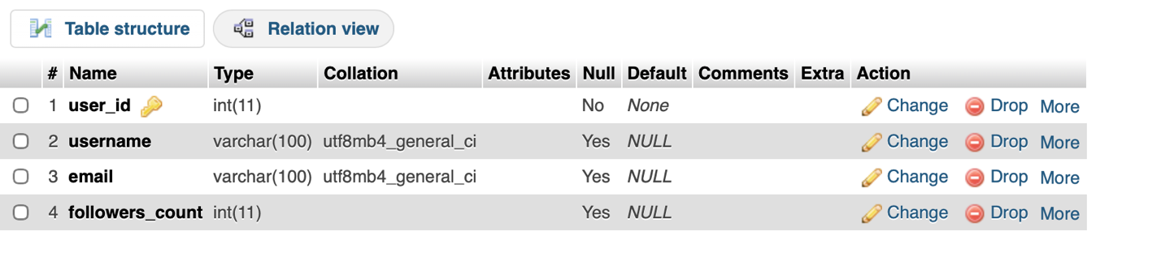

3.Insert 3 sample users into the Users table you created, using realistic Instagram-style usernames and follower counts.

INSERT INTO Users (user_id, username, email, followers_count)
VALUES
(1, 'sanjna', 'sanjna@gmail.com', 5000),
(2, 'neha', 'neha@gmail.com', 3200),
(3, 'jay', 'jay@gmail.com', 7800);

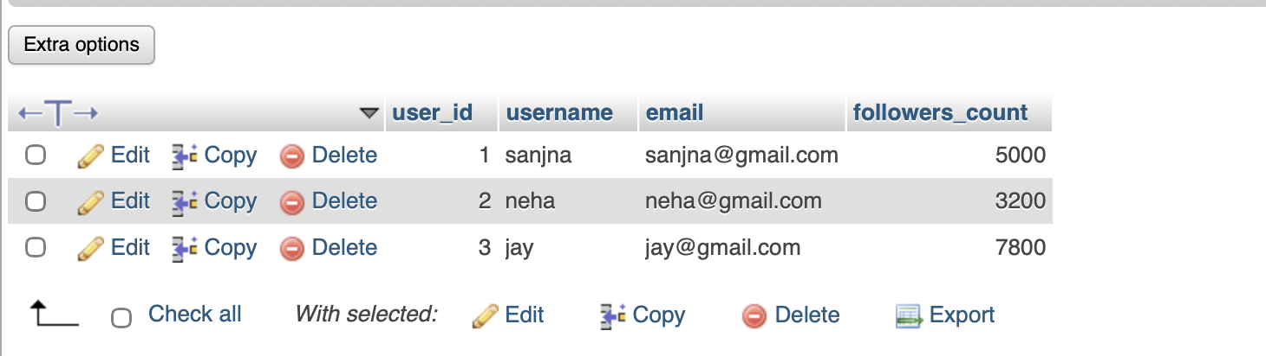

4.Create another table in the InstaClone database called Posts with columns: post_id (INT, primary key), user_id (INT), caption (VARCHAR), and post_date (DATE). Add a foreign key from Posts.user_id to Users.user_id to establish a relationship.
CREATE TABLE Posts (
post_id INT PRIMARY KEY,
user_id INT,
caption VARCHAR(255),
post_date DATE,
FOREIGN KEY (user_id) REFERENCES Users(user_id)
);
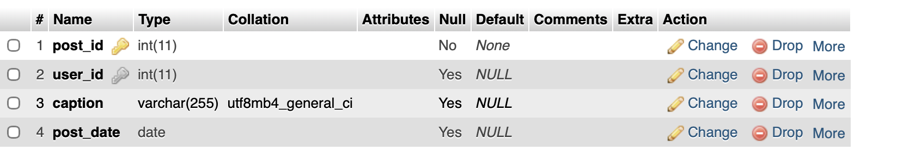

5.Write a short comparison (3-4 lines each) of MySQL, PostgreSQL, Oracle, and SQLite, focusing on where each one is commonly used (for example: web apps, mobile apps, enterprise systems, etc.).

1. MySQL
MySQL is a popular open-source relational database.
It is commonly used for websites and web applications.
It works well with technologies such as PHP, Python and Java.
It is widely used for applications that need a fast and reliable database.

2. PostgreSQL
PostgreSQL is an open-source object-relational database system.
It is commonly used for large and complex applications.
It provides advanced SQL features and strong data integrity.
It is popular in web applications, analytics and backend systems.

3. Oracle
Oracle Database is a powerful commercial relational database system.
It is commonly used by large companies and enterprises.
It is suitable for banking, finance, government and other large-scale systems.
It provides advanced security, scalability and transaction management.

4. SQLite
SQLite is a small, lightweight database that does not require a separate database server.
It is commonly used in mobile applications, desktop applications and embedded systems.
It is especially popular for Android/iOS apps and small projects.
The entire database can be stored in a single file.

